How to Console into an Instance

Note: If you are unable to RDP to your Windows system on either the public or private IP address, you will need to Console into the system.
The screenshots after step 5 will not match the My Cloud screenshot in step 4. Please use your My Cloud details.

Step 1: Download TightVNC Java Viewer at: http://www.tightvnc.com/download/2.7.2/tvnjviewer-2.7.2-bin.zip and install on your Windows computer.
Step 2: Open your Cloud Concierge My Cloud webpage.
Step 3: Click on the > arrow of the system you need to fix.
Step 4: Locate the Console IP address (it also provides you the port # and password).
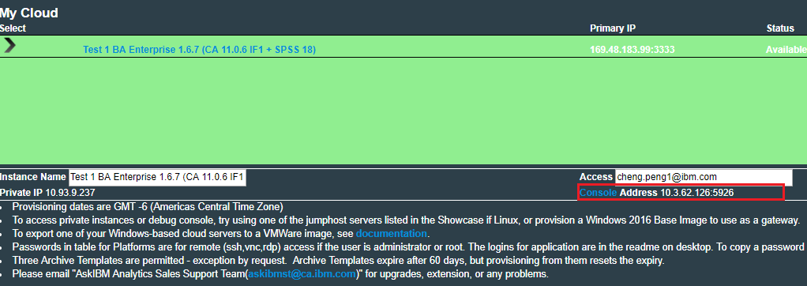
Step 5: Connect to the Softlayer VPN (use link at bottom of My Cloud page if you wish).
Step 6: Launch TightVNC Java Viewer and enter the correct Console IP and Port #.
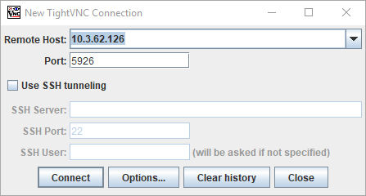
Step 7: You will need to hand type in the password.
Step 8: In TightVNC, click the icon that will send Ctrl-Alt-Del and log into Windows.
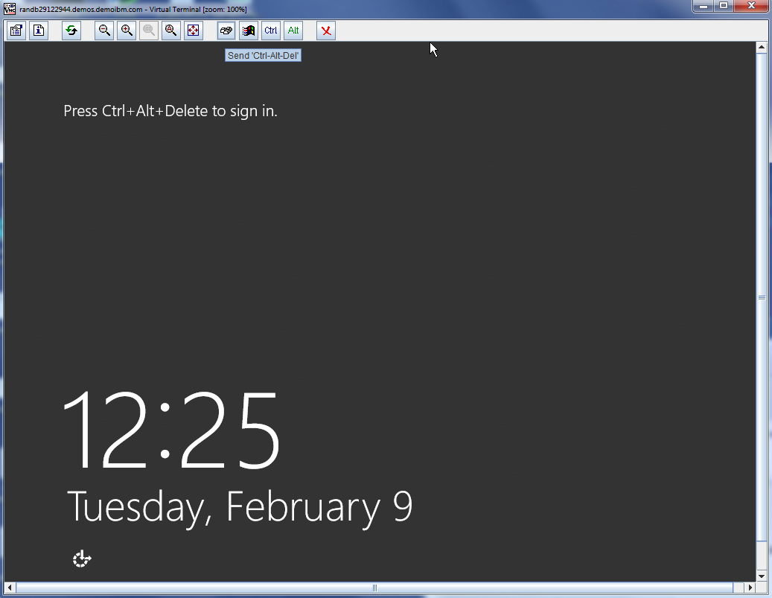
Step 9: On the Taskbar near the clock, right click the networking icon and choose Open Network and Sharing Center.

